H.T No
Regulations:
A14

Sreenidhi Institute of Science and Technology
(An Autonomous Institution)
Code No: 4F302 Date: 13-Oct-2020 (FN)

B.Tech II-Year I-Semester External Examination, October - 2020 (Supplementary)
Mathematical Foundations of Computer Science (CSE and IT)

Time: 2 Hours Max.Marks:70

Note: a) No additional answer sheets will be provided.
b) All sub-parts of a question must be answered at one place only, otherwise it will not be valued.
c) Missing data can be assumed suitably.

ANSWER ANY 5 OUT OF 8 QUESTIONS. EACH QUESTION CARRIES 14 MARKS.

1. | a) | Prove by automatic theorem proving p→(q→r), ¬r∨p, q ⇒ r→s | [7M]
 | b) | Show that p↔q ⇔ (p→q)∧(q→p) | [7M]
2. | a) | Prove that (∀)(x)(P(x)→Q(x)) ∧ (∀)(x)(Q(x)→R(x)) ⇒ (∀)(x)(P(x)→R(x)) | [7M]
 | b) | Solve by generating function a_{n}- 6a_{n-1} + 12a_{n-2} - 8a_{n-3}=0. | [7M]
3. | a) | Define a lattice as an algebraic system. | [7M]
 | b) | Prove or disprove that the set D₃₀ the set of all divisors of 30 forms a Boolean algebra under divisibility ordering. | [7M]
4. | a) | Prove that a Group G is abelian if and only if (ab)⁻¹ =a⁻¹b⁻¹ for all a,b in G. | [7M]
 | b) | Let G be the group of all 2 × 2 nonsingular matrices. Let S be the set of all nonsingular matrices of the form 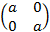. Check whether S is a normal subgroup of G. | [7M]
5. | a) | Let G be a simple graph all of whose vertices have degree 3 and |E|=2|V|-3, What can be said about G? | [7M]
 | b) | Let C_{n} be the cycle graph with n vertices. Prove that C₅ is the only cycle graph isomorphic to its complement. | [7M]
6. | a) | Show that in a connected plane graph |V|-|E|+|R|=2. | [7M]
 | b) | Explain basic rules for constructing Hamiltonian Paths and cycles with examples. | [7M]
7. | a) | Solve the Fibonacci relation F_{n}=F_{n-1}+F_{n-2} for n≥2, given F₀=F₁=1. | [7M]
 | b) | Prove or disprove that if R and S are equivalence relations the R∪S and R∩S are equivalence relations. | [7M]
8. | a) | Apply DFS and BFS algorithms on the following graph.  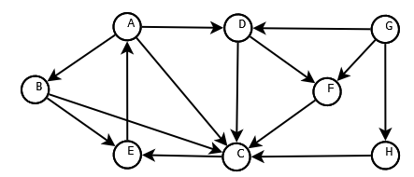 | [7M]
 | b) | Find the minimal spanning tree using Prims and Kruskals algorithms.  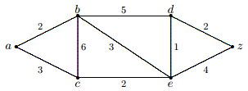 | [7M]

-- 00 -- 00 –

